Debug and Trace

Debug is used while you are developing the product. It depends heavily upon
debug/symbol information that is additionally added to your Debug-mode builds.
When you switch the build options to Release mode, this information, and
any Debug code will not be compiled. The assumption is that you'll no longer
need it because you're done debugging the app and are compiling a release
version. Debug information and code can substantially decrease performance
and efficiency of an executable.
On the other hand, Trace is meant to instrument release builds. This helps
you monitor running code. Think of this like turning on Tracing for ODBC
as an example. Trace is enabled by default, so it's available in Debug and
Release modes, but you can optionally turn Trace compiling off.

Trace and Debug Classes
Fortunately, you do not have to step through an application line by line to figure out what is happening. The Systems.Diagnostics namespace includes Trace and Debug classes. These two classes (which are essentially identical) include a number of static methods that can be used to cause your code to gather information about code-execution paths, code coverage, and even performance profiling. Both classes also provide an Assert method that checks for a condition and displays a message if the condition is false.
To use the Trace and Debug classes, perform the following three steps.
- Define the TRACE or DEBUG symbol.
- Create a new instance of the corresponding Listener.
- Add calls to the Trace or Debug class to your code.
Define — To enable debugging or tracing, you must first define the corresponding symbol. This can be done at compile time using the /d(efine) conditional compilation switch for Visual C# (and the Managed Extensions for C++) or for Visual Basic .NET, as shown here:
Copy Code
csc /target:library /debug+ /d:TRACE math.cs
vbc /target:library /debug+ /d:TRACE=True math.vb
The symbol can also be defined in the source code itself, as shown here:
Copy Code
#define TRACE // for C# or the Managed Extensions for C++
#Const TRACE=1 ' for Visual Basic .NET
Create — Both Debug and Trace output are captured by a TraceListener. By default, output is automatically sent to the DefaultTraceListener, which sends output to the Windows system debugger using the OutputDebugString Windows API and to the debugger using the Debugger.Log method. Messages sent using Debugger.Log have no effect if there is no debugger attached.
If you are operating inside the Windows-based debugger, the Output window will show Debug and Trace messages. However, if you are running outside the debugger — for example, on a tester's computer — or if you want to save debugging information to a text-based log file, you must create a new Listener and add it to the Listeners collection. The System.Diagnostic namespace provides an EventLogTraceListener and a TextWriterTraceListener. Creating a text file to handle debugging messages requires only the following single line of code.
Copy Code
Trace.Listeners.Add(new
TextWriterTraceListener(File.Create("output.txt")));
Add — Lastly, you can add calls to the various Trace.Write methods to generate debugging information at run time, as shown here:
Copy Code
Trace.WriteLine("");
Trace.WriteLine("Starting tracing...");
Because the first few bytes of the output file contain information about the text encoding of the file and are not readable, you might want to start logging on a new line, by first executing an empty WriteLine method.
The next thing to notice is the call to Trace.Indent, which by default indents the output by four spaces:
Copy Code
Trace.Indent();
Subsequent calls to Trace.Unindent will justify the output back towards the left.
This sample program also uses the WriteLineIf method of Trace to generate a logging message, but only if a certain condition is not met. In this particular case, the code anticipates that the first numeric entry will begin with a digit other than zero. If that test fails, a message is written, as shown in the following line.
Copy Code
Trace.WriteLineIf(test == "0", "Oops: Leading zero"); // C#
Trace.WriteLineIf(test = "0", "Oops: Leading zero") ' VB
Putting all this together, executing the sample program creates the following Output.txt file.
Copy Code
Starting Tracing...
InitializeComponent()
Creating controls
Setting up Label and TextBox
Setting up numeric buttons
Setting up operations buttons
Adding Clear and Calculate
Adding to Controls collection
9 Clicked
- Clicked
6 Clicked
Calculate Clicked
Dispose()
The Assert method operates in a similar fashion, except that the output is in the form of a detailed error dialog, and the test fails. The corresponding Assert method looks like the following code.
Copy Code
Trace.Assert(test != "0", "Oops", "Leading zero"); // C#
Trace.Assert(test <> "0", "Oops", "Leading zero") ' Visual Basic .NET
When Calc.exe is run and the user enters a leading zero, the following dialog box is produced.
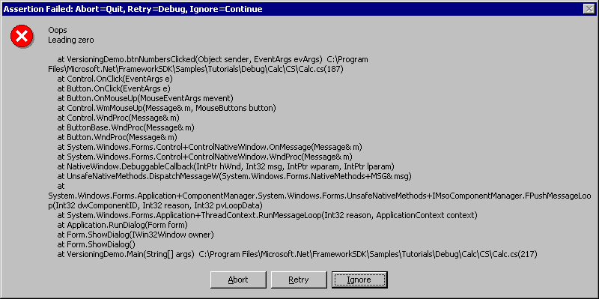
Note If your program fails to run to completion, a 0-byte Output.txt file will be produced.

Compiling Conditionally with Trace and Debug
While you are debugging an application during development, both your tracing and debugging output go to the Output window in Visual Studio. However, to include tracing features in a deployed application, you must compile your instrumented applications with the TRACE compiler directive enabled. This allows tracing code to be compiled into the release version of your application. If you do not enable the TRACE directive, all tracing code is ignored during compilation and is not included in the executable code that you will deploy.
Both the tracing and debugging methods have associated conditional attributes. For example, if the conditional attribute for tracing is true, all trace statements are included within an assembly (a compiled .exe file or .dll); if the Trace conditional attribute is false, the trace statements are not included.
You can have either the Trace or Debug conditional attribute turned on for a build, or both, or neither. Thus, there are four types of build: Debug, Trace, both, or neither. Some release builds for production deployment might contain neither; most debugging builds contain both.
You can specify the compiler settings for your application in several ways:
- The property pages
- The command line
- #CONST (for Visual Basic) and #define (for C#)
To change compile settings from the property pages dialog box
- Right-click the project node in Solution Explorer.
- Choose Properties from the shortcut menu.
- In the Property Page dialog box that appears, click the Configuration Properties tab in the left pane and choose the Build option.
- Choose the desired compiler settings.
  - In Visual Basic, select the check boxes for the compiler settings you want to enable. Clear the check boxes for settings you want to disable.
  - In C#, in the Conditional Compilation Constants field, type the name of the setting you want to enable.
Visual C# Note To enable both Debug and Trace, type DEBUG;TRACE (or TRACE;DEBUG). Delete the name of any setting you want to disable. C# is case-sensitive, and the setting names must be uppercase.
To compile instrumented code using the command line
- Set a conditional compiler switch on the command line. The compiler will include trace or debug code in the executable.
For example, the following compiler instruction entered on the command line would include your tracing code in a compiled executable:
For Visual Basic: vbc /r:System.dll /d:TRACE=TRUE /d:DEBUG=FALSE MyApplication.vb
For C#: csc /r:System.dll /d:TRACE /d:DEBUG=FALSE MyApplication.cs
Tip To compile more than one application file, leave a blank space between the file names, for example, MyApplication1.vb MyApplication2.vb MyApplication3.vb or MyApplication1.cs MyApplication2.cs MyApplication3.cs.
The meaning of the conditional-compilation directives used in the above examples is as follows:
Directive | Meaning
vbc | Visual Basic compiler
csc | C# compiler
/r: | References an external assembly (EXE or DLL)
/d: | Defines a conditional compilation symbol
Note You must spell TRACE or DEBUG with uppercase letters. For more information about the conditional compilation commands, enter vbc /? (for Visual Basic) or csc /? (for C#) at the command prompt. For more information, see Building from the Command Line (C#) or Invoking the Command-Line Compiler (Visual Basic).
To perform conditional compilation using #CONST or #define
- Type the appropriate statement for your programming language at the top of the source code file.
Language | Statement | Result
Visual Basic | #CONST TRACE = true | Enables tracing
 | #CONST TRACE = false | Disables tracing
 | #CONST DEBUG = true | Enables debugging
 | #CONST DEBUG = false | Disables debugging
C# | #define TRACE | Enables tracing
 | #undefine TRACE | Disables tracing
 | #define DEBUG | Enables debugging
 | #undefine DEBUG | Disables debugging
To disable tracing or debugging
- Delete the compiler directive from your source code.
- or -
- Comment out the compiler directive.
Note When you are ready to compile, you can either choose Build from the Build menu, or use the command line method but without typing the d: to define conditional compilation symbols.

